**Getting Started Manual**

1. System Configuration  
    2x PXI 8880 with Windows and Ubuntu 20.4 systems  
   2x PXIe-8238 PXI Ethernet Interface Module
2. Install ROS 1  
    [Noetic](http://wiki.ros.org/noetic)on Ubuntu

  
[Ubuntu install of ROS Noetic](http://wiki.ros.org/noetic/Installation/Ubuntu)  
[ROS Tutorials](http://wiki.ros.org/ROS/Tutorials)

1. ROS Subscriber Code  
   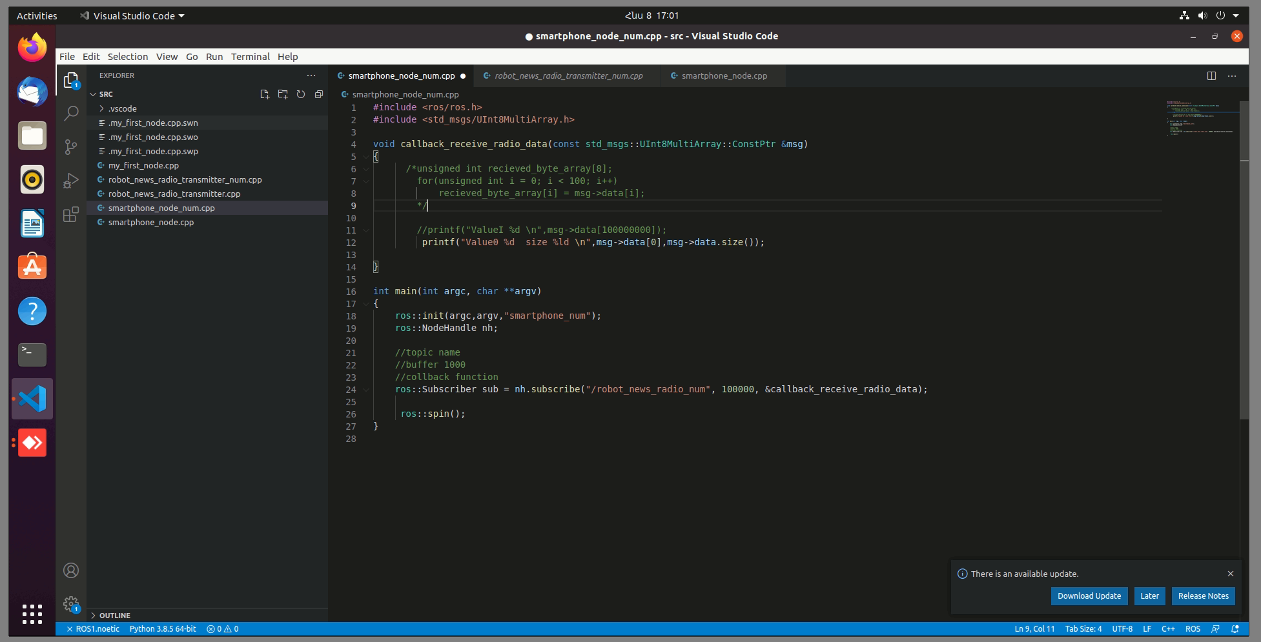
2. C# Open Source [Git](https://github.com/uml-robotics/ROS.NET) Library for ROS (Template_ROS_dotNET.sln)  
   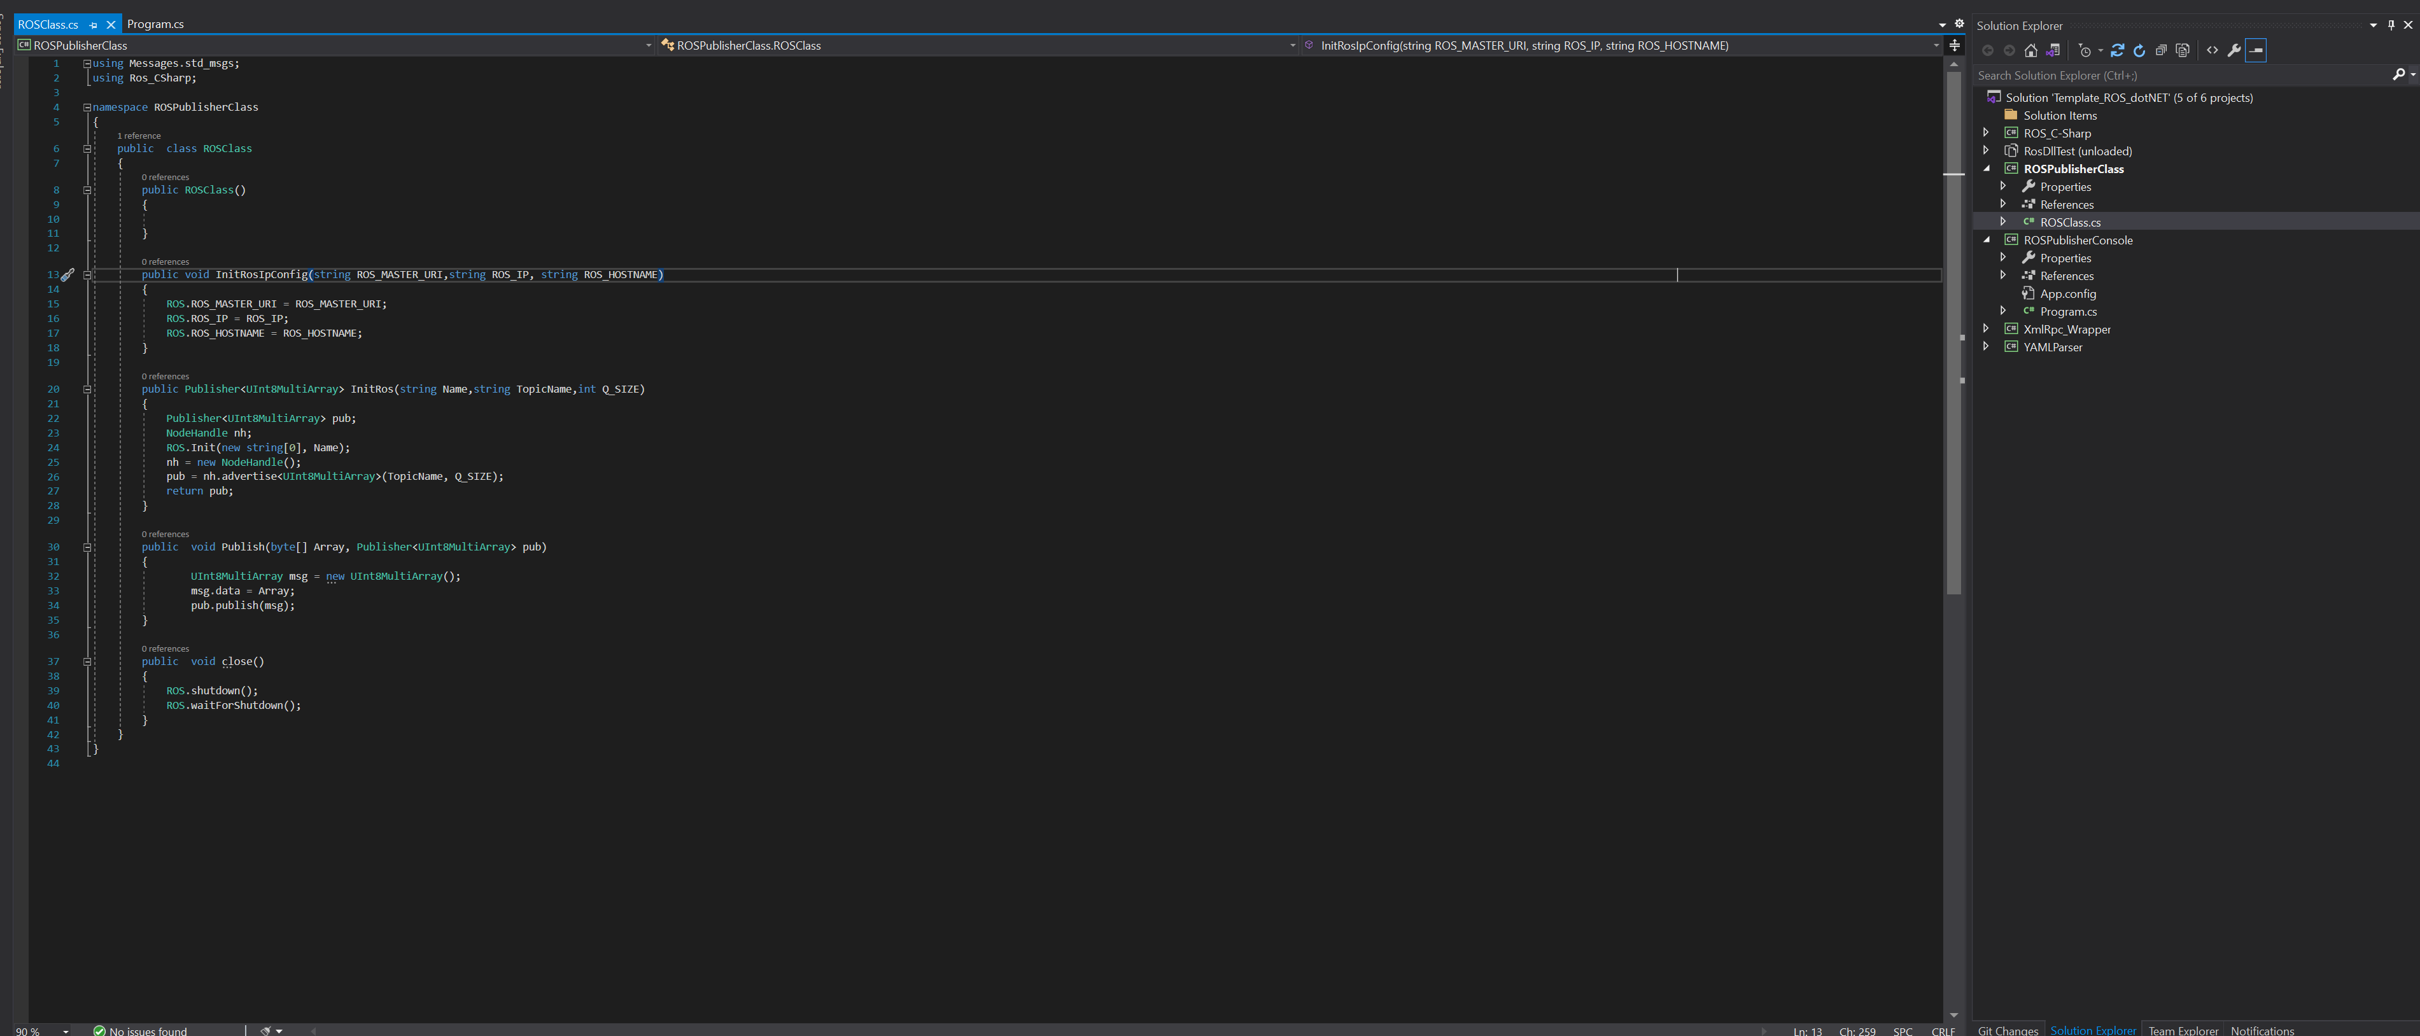
3. Integrated C# DLL to LV environment  
   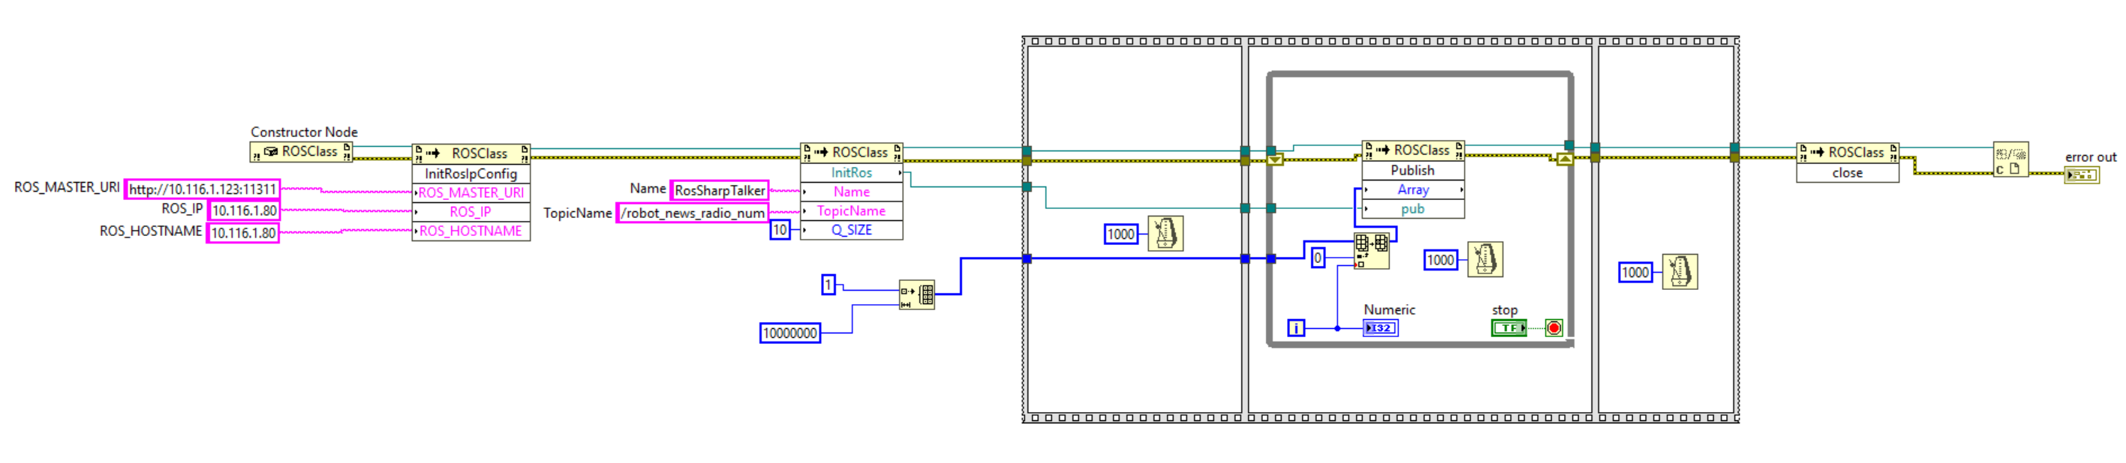
4. Some ROS commands on Ubuntu  
    catkin_make

source devel/setup.bash

export ROS_HOSTNAME=10.116.1.12

export ROS_IP=10.116.1.12

export ROS_MASTER_URI=http://10.116.1.12:11311

roscore

rosrun my_robot_tutorials smartphone_node_num

rosrun my_robot_tutorials robot_news_radio_transmitter_num

1. TCP Benchmarking tool [iPerf](https://iperf.fr/)
2. Attached Files  
     
   catkin_ws -> Ubuntu PXI code  
   ROS.NET-master -> C# Code  
   ROS_Publish.vi -> LabView Publisher vi  
   10Gb_s ROS Benchmark CSharp (4Gb_s)